BESAFE WEBAPPLICATION

**1.INTRODUCTION:**

**1.1 OVERVIEW:**

Our whole nation is fighting against COVID-19. Millions of people had lost their lives ;lost their loved ones; many dreams and goals has been given up. But on the other side people roaming in the midst of pandemic without any prior precautions, social distancing, masks….so and so.

We must understand the struggle of doctors, nurses and other employees towards Covid free nation. Atleast we must have a common awareness towards this deadly virus. Start it from your area. Are you aware of containment zones? Atleast Do you have an idea whether your area is under containment zone or not?...

But how to keep yourself updated about the containment zones?

HERE WE GO….

I have developed a **BESAFE** Webapp in which you can verify your area with containment zones.It also provides you with the our nation’s covid counts.

**1.2 PURPOSE:**

You can check whether your area is under containment zone or not.Also you can view the list of containment zone you have visited.In Dashboard you can also have a look on live counts of our nation’s activecases,newcases,deaths and recovered cases.By verifying your area with containment zones you can protect yourself by taking necessary precautions.You can also get updated with the covid count using this webapp.

**2.LITERATURE SURVEY:**

**2.1 EXISITING PROBLEM:**

Google has added a new feature to Google Maps which displays the containment zones in it.The feature has been brought about in Mumbai, as of now, and will expand to other cities in India soon.There are also many hotspot trackers developed by private developers.

**2.1 PROPOSED SOLUTION:**

This webapp is developed in such a way admin can add or delete a containment zone.If the user entered zone matches with the containment zone,it gives the warning message .By using this webapp you can verify your area with containment zones instantly and also you can view the list of containment zones you have visited.You can also view the counts of covid activecases, newcases , deaths and recovered cases instantly.

**3.THEORETICAL ANALYSIS:**

**3.1 FLOWCHART:**

ADMIN

ZONE/COUNT UPDATE

CREDENTIALS

DATABASE

USER

COUNT

VISITED ZONES

LOCATION

VERIFY

“YOU ARE CURRENTLY IN A CONATAINMENT ZONE”

“YOU ARE CURRENTLY NOT IN A CONATAINMENT ZONE”

NOT A CONTAINMENT ZONE

CONTAINMENT ZONE

**3.2 HARDWARE / SOFTWARE DESIGNING:**

PC or Smartphone with a browser and active internet connection is enough.

**4.EXPERIMENTAL INVESTIGATIONS:**

The list of containment zones have been investigated while working on the solution.

**5.FLOWCHART:**

ADMIN

ZONE/COUNT UPDATE

CREDENTIALS

DATABASE

USER

COUNT

VISITED ZONES

LOCATION

VERIFY

“YOU ARE CURRENTLY IN A CONATAINMENT ZONE”

“YOU ARE CURRENTLY NOT IN A CONATAINMENT ZONE”

NOT A CONTAINMENT ZONE

CONTAINMENT ZONE

**6.RESULT:**

**HOMEPAGE:**

Firstly, You will be driven to the homepage.

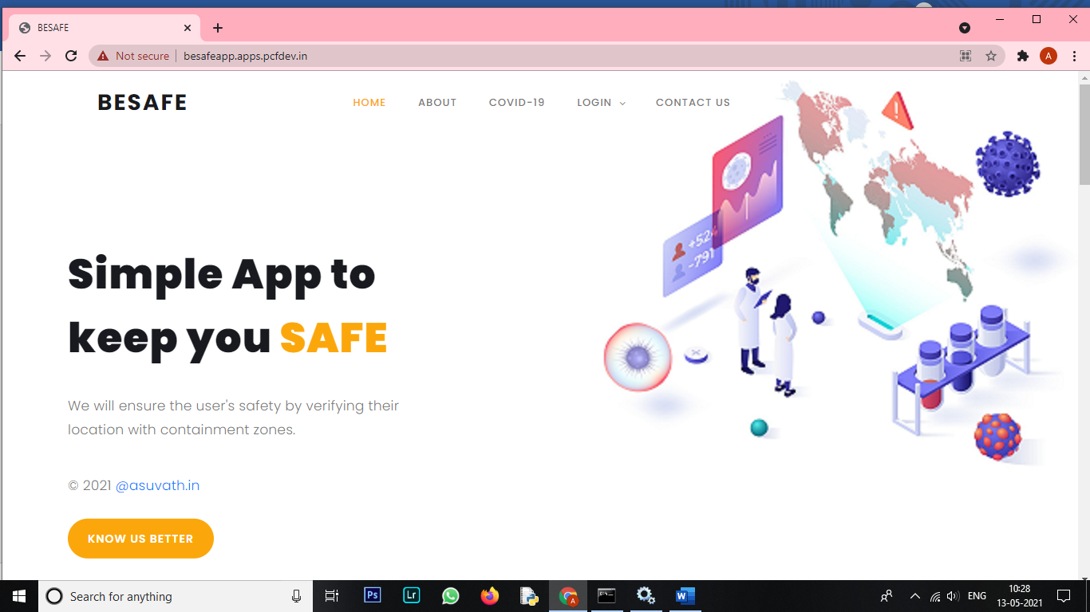

Click on LOGIN at the top bar

If you are a first time user the click NEW USER orelse go with EXISTING USER.

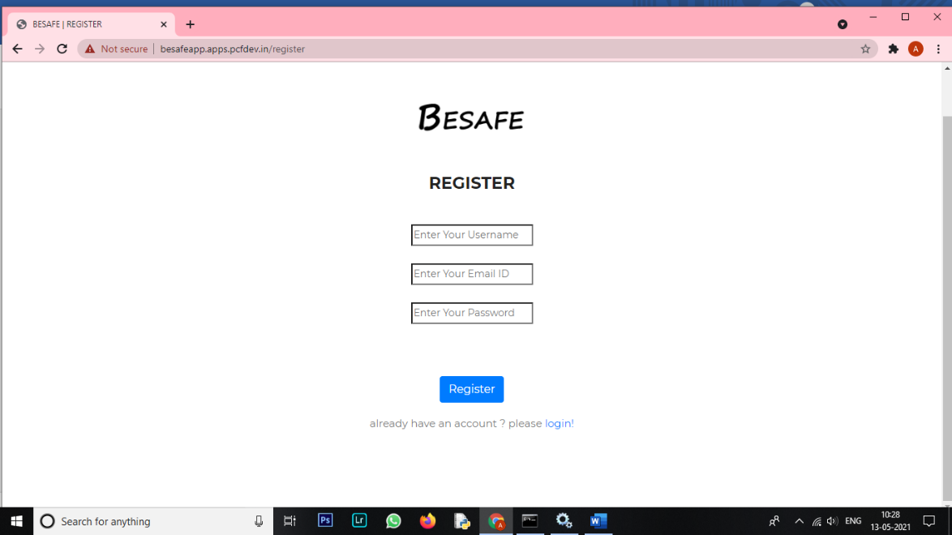

After registration enter your valid credentials and get logged in.

**DASHBOARD:**

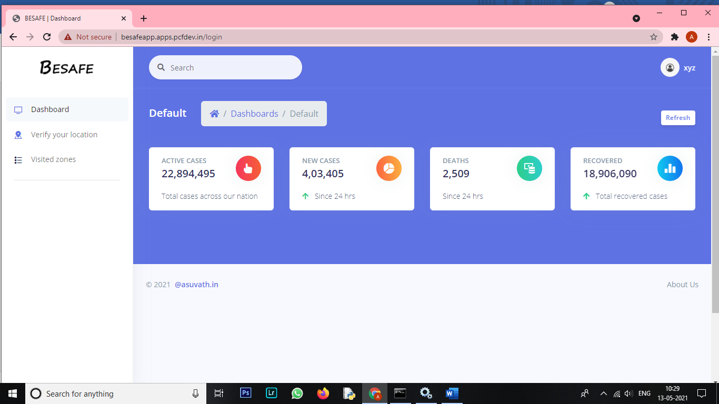

After getting logged in, you will be at the dashboard page in which you can see all the updates of our nation’s covid count.

**VERIFY YOUR LOCATION:**

Click  **VERIFY YOUR LOCATION** at the left to verify your area.

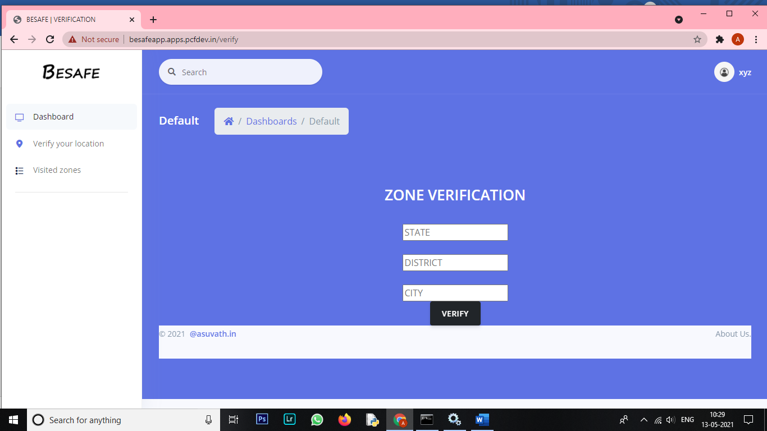

Provide the valid details of your area and click **VERIFY.**

If your area is under containment zones:

You will be displayed with “**YOU ARE CURRENTLY IN A CONTAINMENT ZONE”**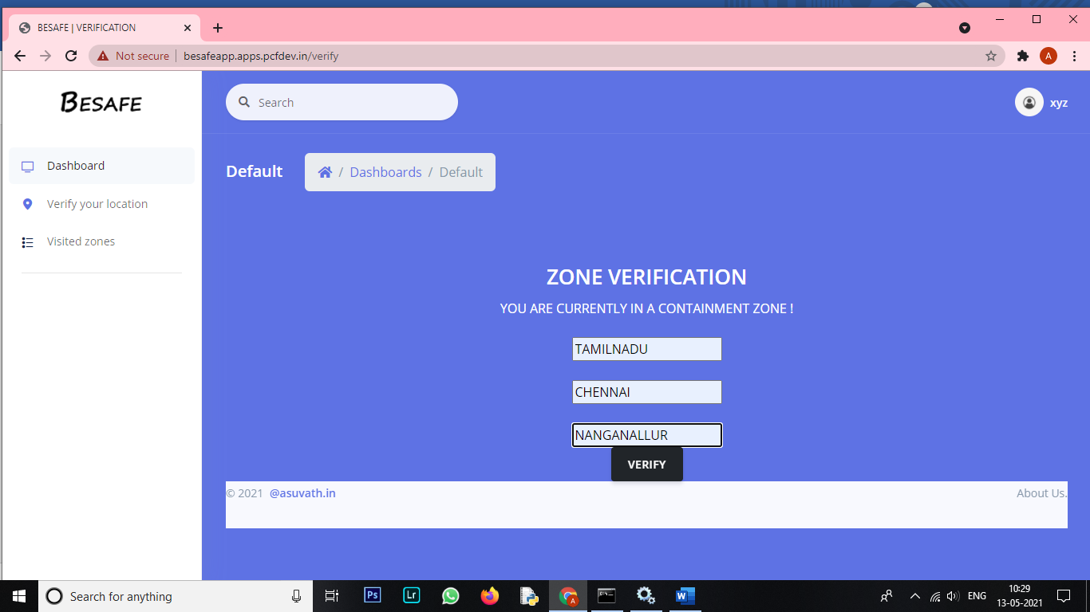

If your area is not under containment zones:

You will be displayed with “**YOU ARE CURRENTLY NOT IN A CONTAINMENT ZONE”**

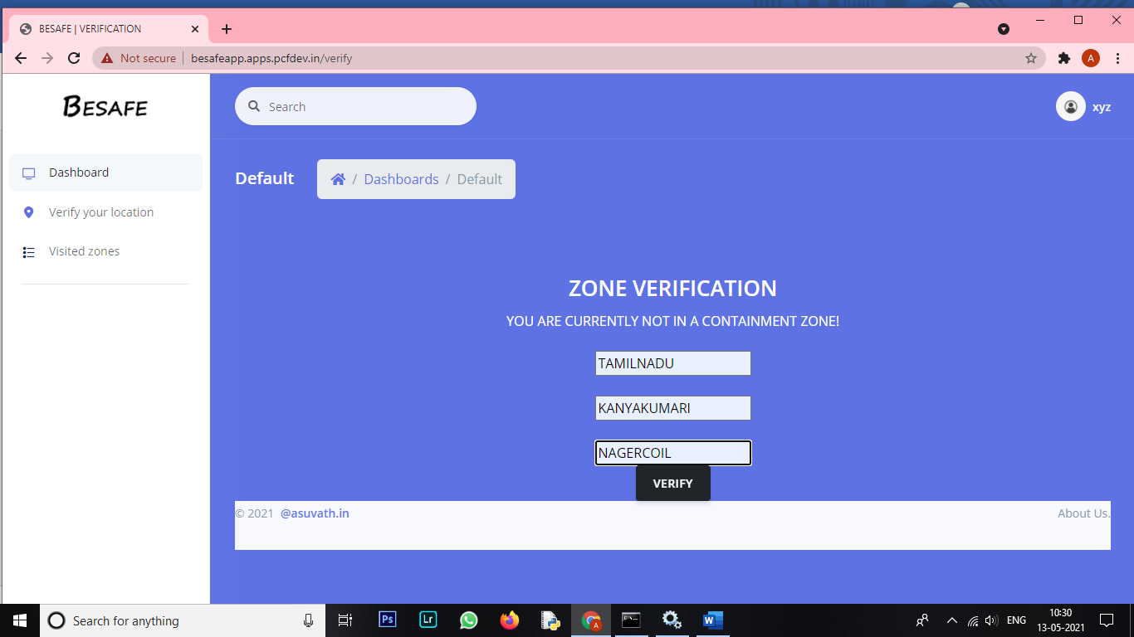

**VISITED ZONES:**

You can also view the containment zones that you have visited by clicking **VISITED ZONES** at the left.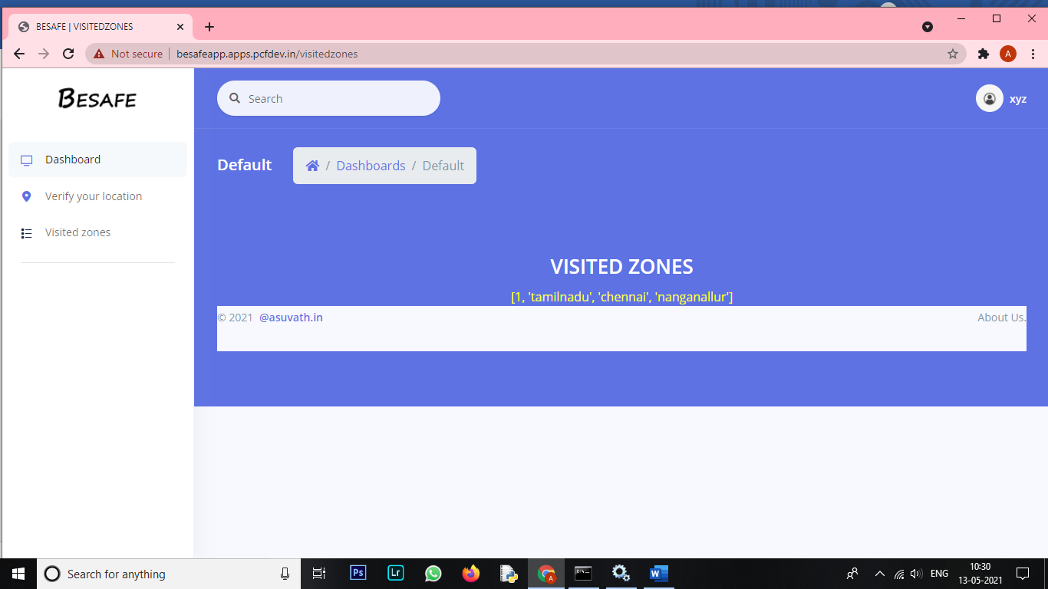

**LOGOUT:**

You can log out of the session by clicking your username at the top right corner and then click **LOGOUT.**You will be logged out of the session and redirected to HOMEPAGE.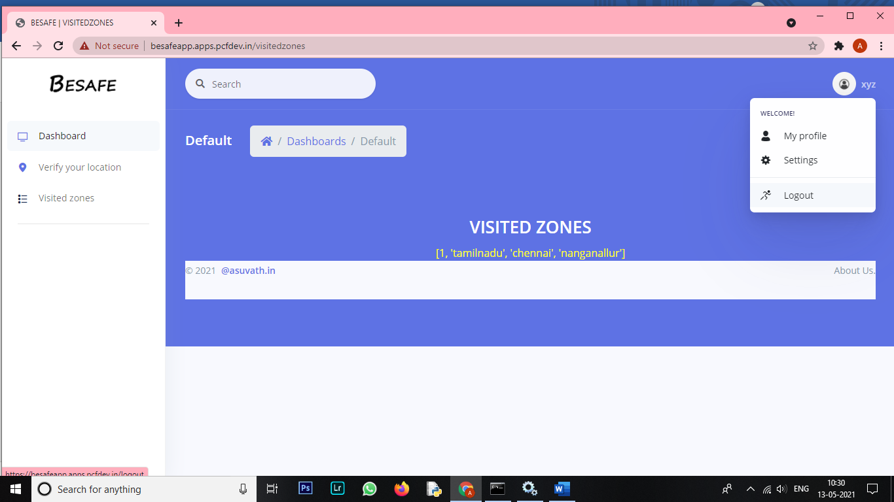

**7.ADVANTAGES AND DISADVANTAGES:**

You can verify your location with containment zones instantly and also you can view the list of containment zones you have visited.You can also view the counts of covid activecases, newcases , deaths and recovered cases instantly.

But the webapp is currently admin entry based and the activity of admin is highly required for this webapp.

**8.APPLICATIONS:**

This web application can be applied in any place as it depends only on the admin entries.It can be also altered for other zones according to the needs.

**9.CONCLUSION:**

Its every citizens responsibility to help our nation towards covid free country.Lets start it form our area.Get updated with your area’s containment zone status.Maintain social distancing and take necessary precaution for a better future.BE AWARE! BE UPDATED!

**10.FUTURE SCOPE:**

In future,the webapp can be enhanced by adding features like geofences,live location tracking,mail alerts and user supports.

THANK YOU

-M.S.ASUVATH,

Vel Tech Multi Tech Dr.Rangarajan Dr.Sakunthala Engineering College ,

Chennai,Tamilnadu.